Day -2

8:00 – 9:40

1. Given an array of integers, find the maximum difference between any two elements in the array.

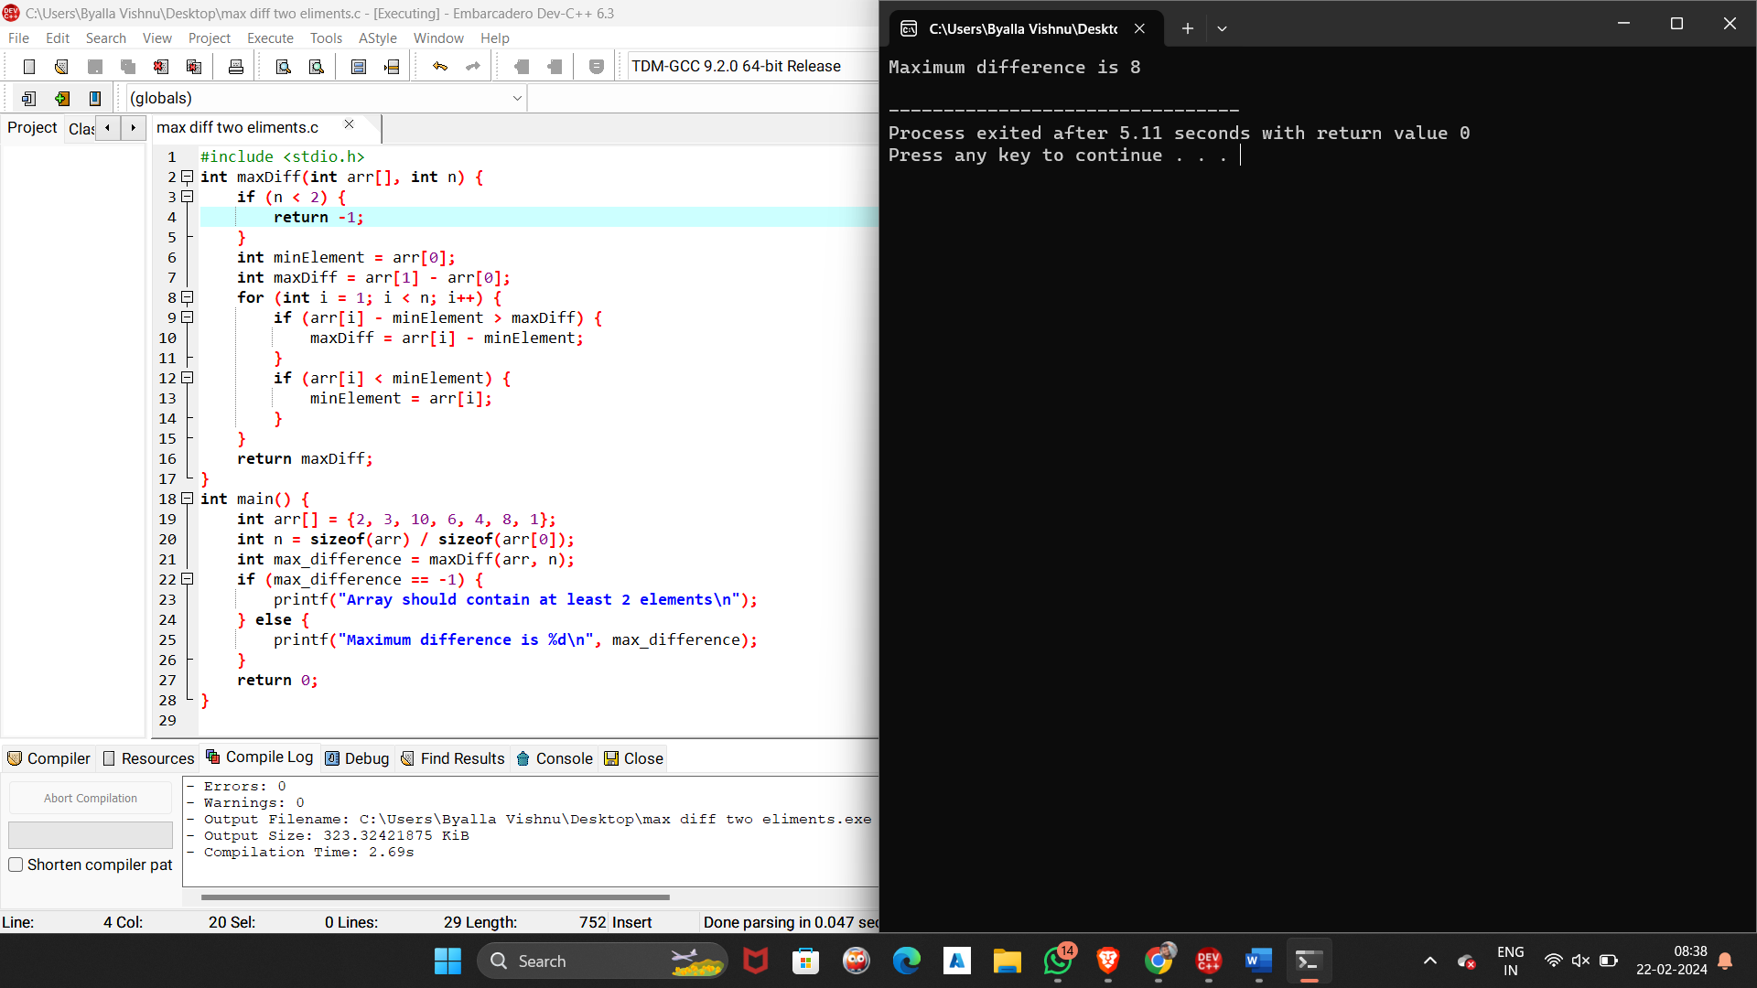

2. Given two arrays of integers, find the common elements between them.

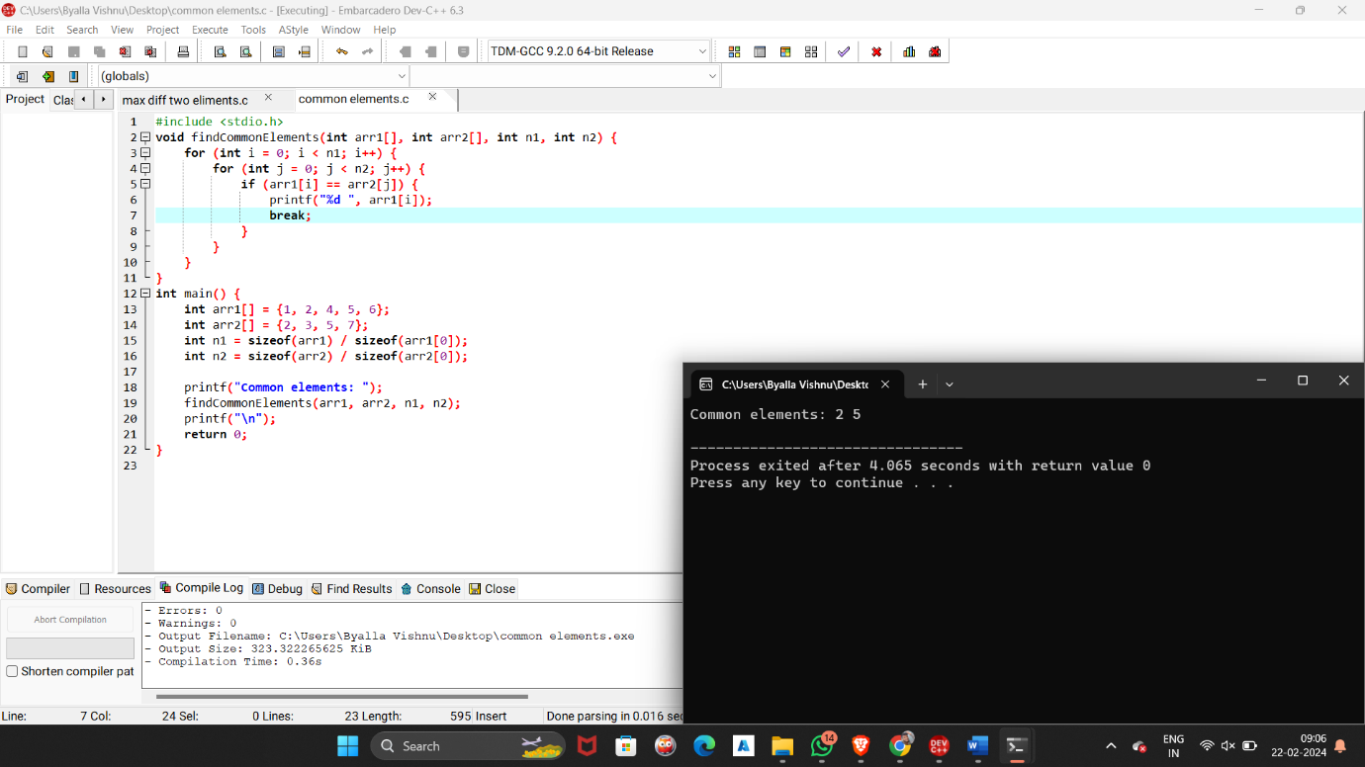

3. Given an array of integers, find the two elements that have the maximum product.

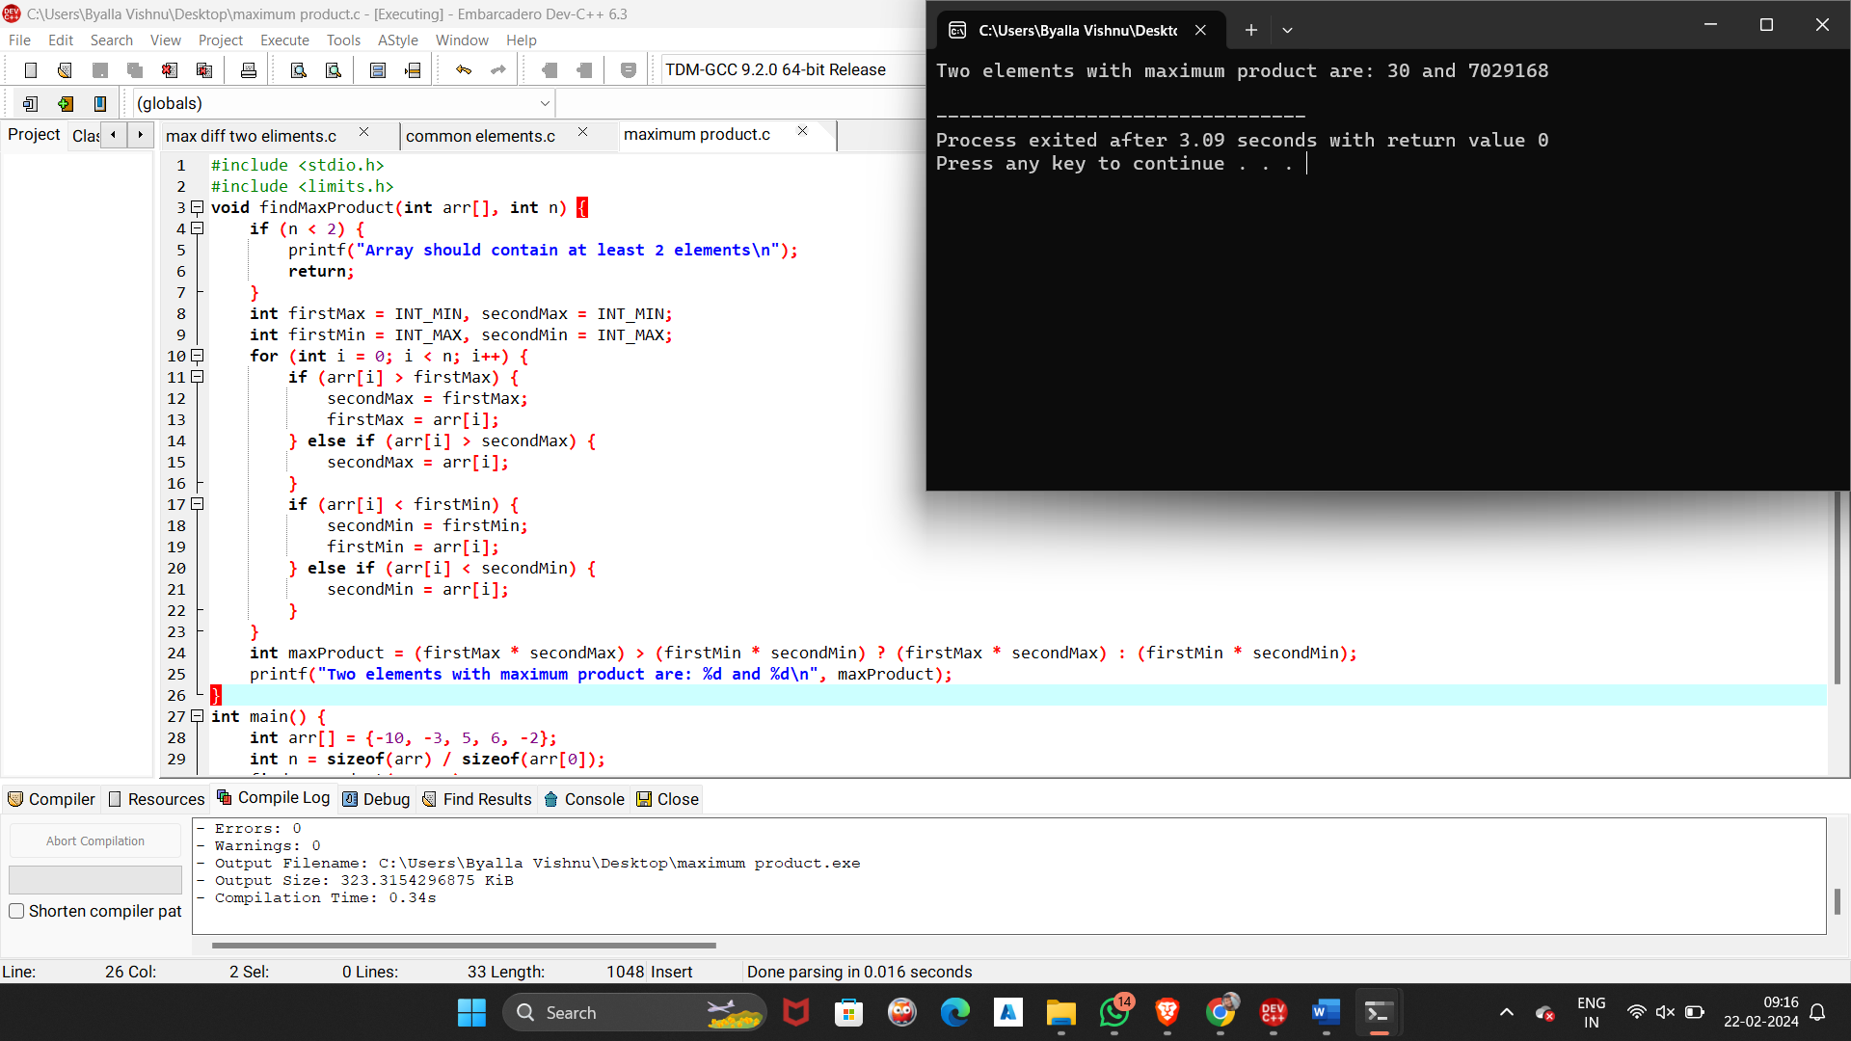

4.Given an array of integers, find the subarray with the maximum product

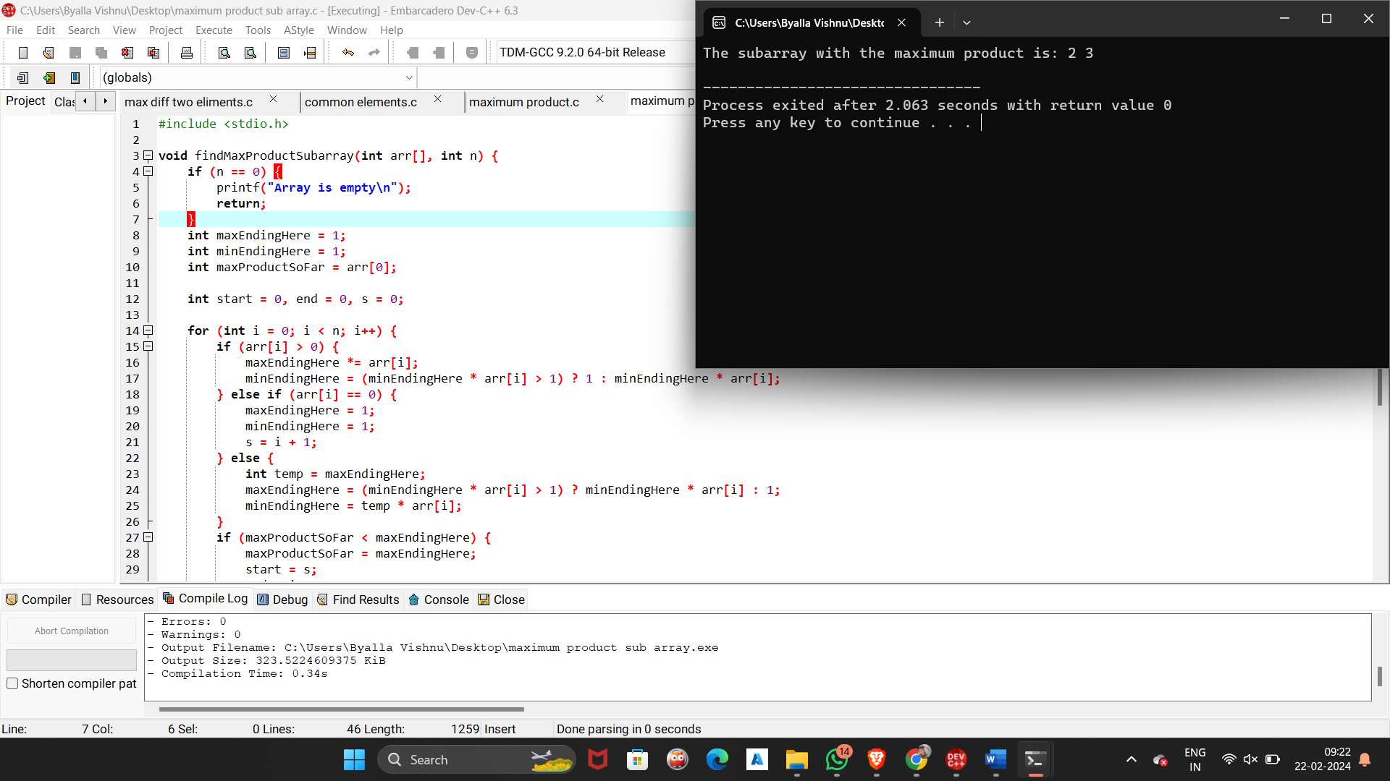

5.Given an array of integers, find the longest subarray with the given sum.

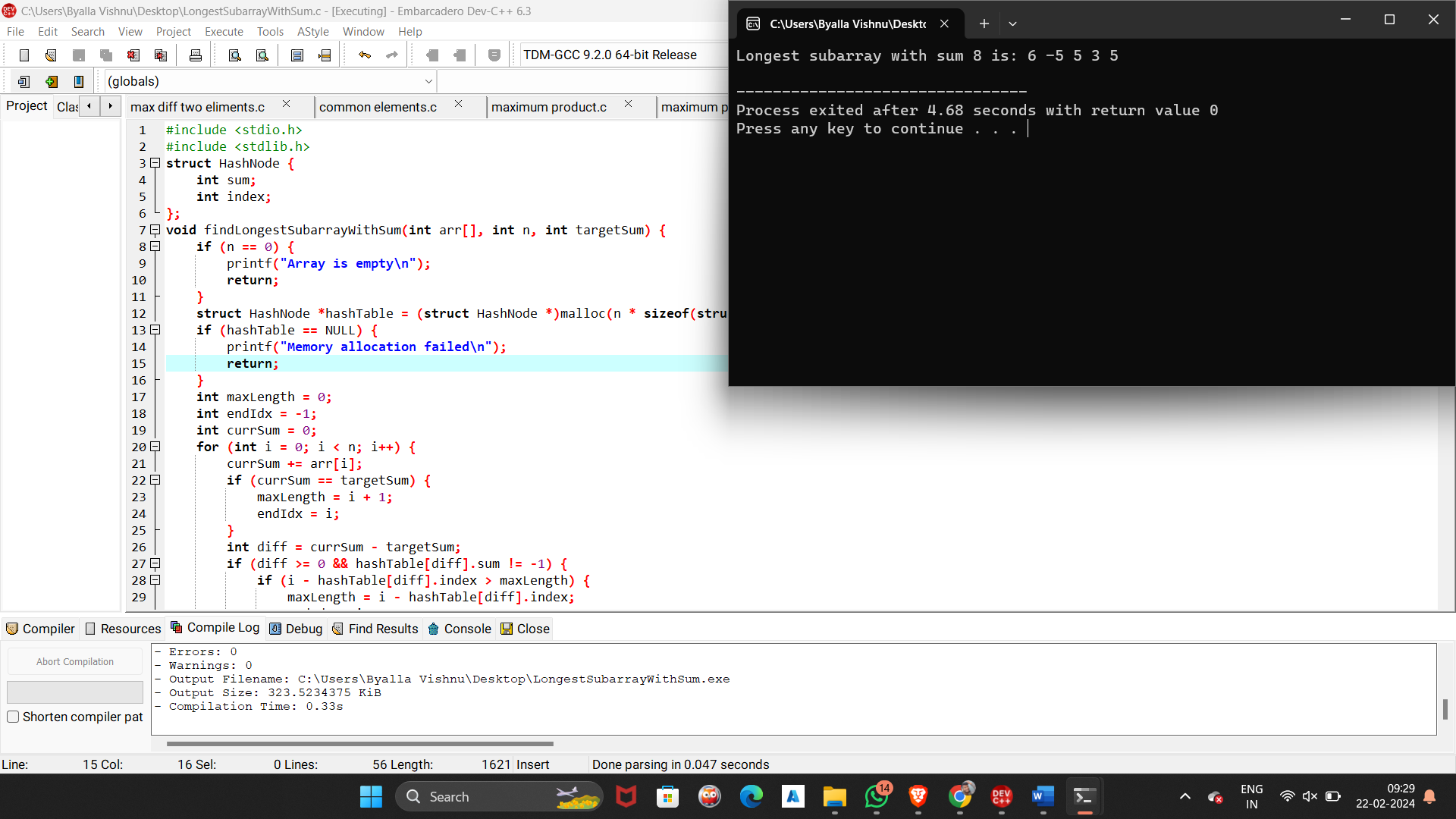

1. Write a program to swap the values of two variables using pointers.

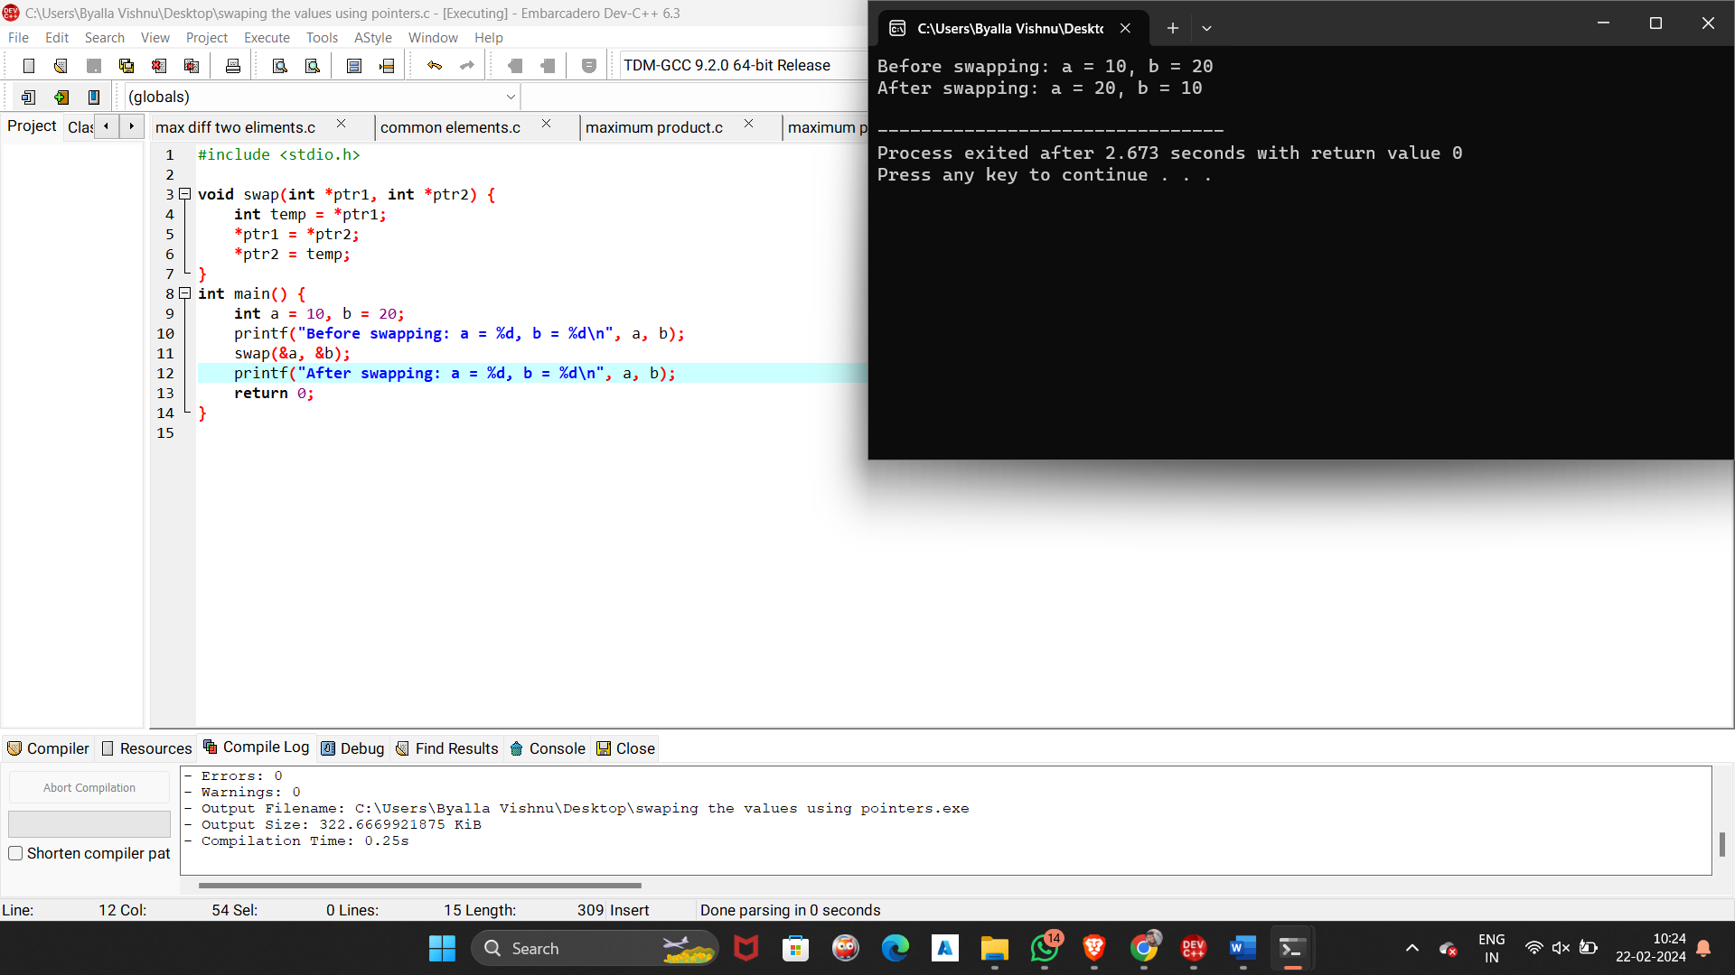

7. Write a program to find the length of a string using pointers

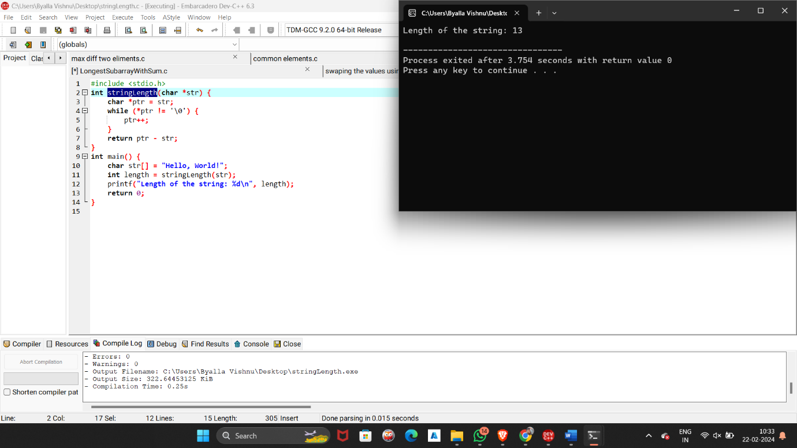

8.Write a program to count the number of occurrences of a character in a string using pointers.

